Name Date

5.3/5.4

Practice A

**Write a rate that represents the situation.**

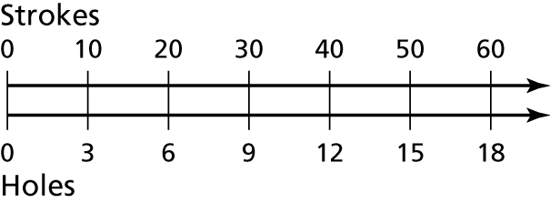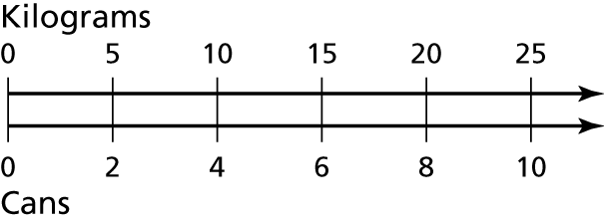 **1.** **2.**

**Write a unit rate for the situation.**

**3.** $44 in 4 days **4.** 12 haircuts in 4 hours

**5.** 256 heartbeats in 4 minutes **6.** 15 liters in 3 minutes

**Decide whether the rates are equivalent.**

**7.** 17 heartbeats in 15 seconds, **8.** 96 miles on 4 gallons,

68 heartbeats in 60 seconds 380 miles on 15 gallons

**9.** You receive 9 text messages in 12 minutes. What is the rate of text messages per hour?

**10.** A deli sells a sandwich spread for $6.40 per pound. How much do you have to pay for 24 ounces of the spread?

**11.** You can buy 3 sandwiches for $4.95 or 4 sandwiches for $6.72. Which is the better buy?

**12.** You can buy 20 ounces of cereal for $4.40 or 16 ounces of the same brand for $3.68. Which is the better buy?

Determine which car gets the better gas mileage.

|  |  |  |
| --- | --- | --- |
| Car | A | B |
| Distance (miles) | 400 | 440 |
| Gallons used | 12 | 15 |

|  |  |  |
| --- | --- | --- |
| Car | A | B |
| Distance (miles) | 130 | 125 |
| Gallons used | 8 | 9 |

1. 2.

Determine which is the better buy.

3. 4.

|  |  |  |
| --- | --- | --- |
| Pens | A | B |
| Cost (dollars) | 5 | 2 |
| Pens | 20 | 7 |

|  |  |  |
| --- | --- | --- |
| Chord Charts | A | B |
| Cost (dollars) | 13 | 18 |
| Downloads | 10 | 15 |

Complete the ratio tables and graph the ordered pairs from the table. What can you conclude?

5.

|  |  |
| --- | --- |
| Orlando, FL | |
| Time (min) | Temperature Drop (F) |
| 3 | 1 |
| 6 |  |
| 9 |  |
| 12 |  |

|  |  |
| --- | --- |
| Miami, FL | |
| Time (min) | Temperature Drop (F) |
| 5 | 2 |
| 10 |  |
| 15 |  |
| 20 |  |

6. You are choosing a song for your dance recital. Song A has 11 beats   
in 10 seconds. Song B has 7 beats in 6 seconds. Which song has the   
greater rate?